**Google Data Studio / Analytics Report Creation**

Statement of Work (SOW)

Table of Contents

1 Project Brief 2

2 Task 2

3 Dashboard Report 2

4 Project Discussions 2

5 Meeting Recording 3

6 Deliverable 3

# Project Brief

Hi - We are seeking someone we may call on to create and customize Google Data Studio reports for websites we create. You should be able to understand written and verbal American English very well. You should be be able to crank out data studio reports quickly and suggest options we haven't considered.

# Task

 Here is a video overview: <https://www.loom.com/share/524b5f158b864fa3822d46cc58d9bb1e>

Written instructions:

(1) Change Event Count to Pages / Session

(2) Remove all but top 3 conversions. Make chart readable.

(3) Popular pages - exclude silly pages and make readable and eliminate one of the 2 visualizations showing the same thing.

(4) Site Search should display top searches. (Since it is an autocomplete I hope to figure out a way to remove all/most of the partials.

# Dashboard Report

Here is the report so far:

<https://datastudio.google.com/u/0/reporting/2d24e02c-433a-4bef-95cb-b1471ee567e9/page/4VDGB>

Access to [blackcofferconsulting@gmail.com](mailto:blackcofferconsulting@gmail.com)

# Project Discussions

Skype

# Meeting Recording

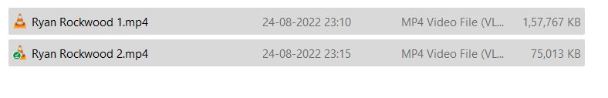

# Deliverable

Fully Functional Google Data Studio Dashboard